目录

Tenda ac23 V16.03.07.45_cn 2

1. formWifiBasicSet->sub_451DF8->sub_450EE4 ->v18； 2

2. The saveParentControlInfo function has a string overflow parameter deviceId.String overflow due to insufficient storage space allocation 3

3. The saveParentControlInfo->compare_parentcontrol_time function has a stack overflow time parameter 4

4. formSetPPTPServer->sub_4781A4 function has a stackoverflow 6

5. fromSetRouteStatic->save_staticroute_data has a stack overflow vulnerability 8

6. formSetVirtualSer->save_virtualser_data function a stack overflow vulnerability triggered by the list parameter 9

7. The mDMZSetCfg function parameter dmzIp has a stack overflow is triggered by the list parameter 10

8.The stack overflow is triggered in the fromSetIpMacBind->sub_48E668 stack overflow parameter list->sub_48E668 11

9. formSetRebootTimer->sub_497154 stack overflow: The parameter rebootTime->sub_497154 triggers stack overflow 14

10. fromAdvSetMacMtuWan has a stack overflow vulnerability.Trigger function sub_44C7A8 16

11.formWifiBasicSet->sub_451DF8->sub_450EE4->sub_450A4C 17

# Tenda ac23 V16.03.07.45_cn

## 1. formWifiBasicSet->sub_451DF8->sub_450EE4 ->v18；

When the user submits too many parameters, it will cause the function to set_idx_to_mib v18 beyond the preset range, resulting in stack overflow. 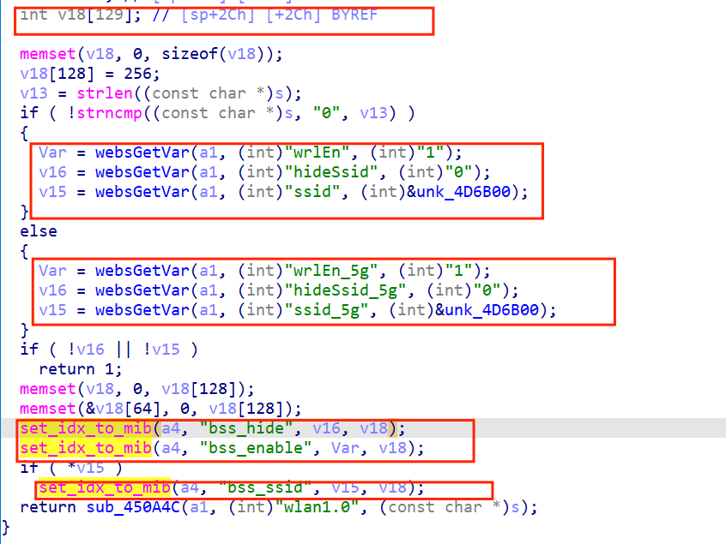

poc:

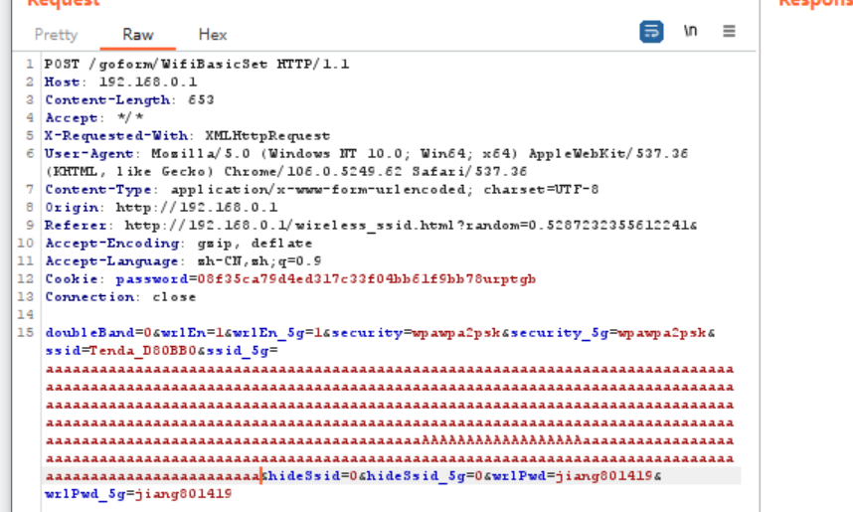

## 2. The saveParentControlInfo function has a string overflow parameter deviceId.String overflow due to insufficient storage space allocation

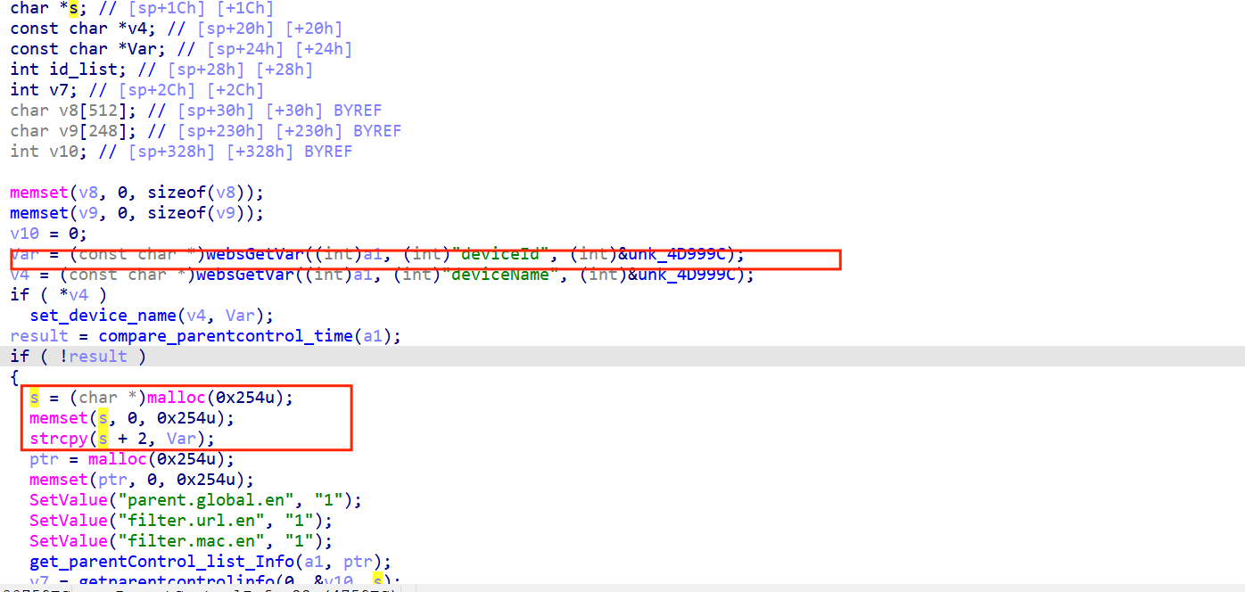

Poc：

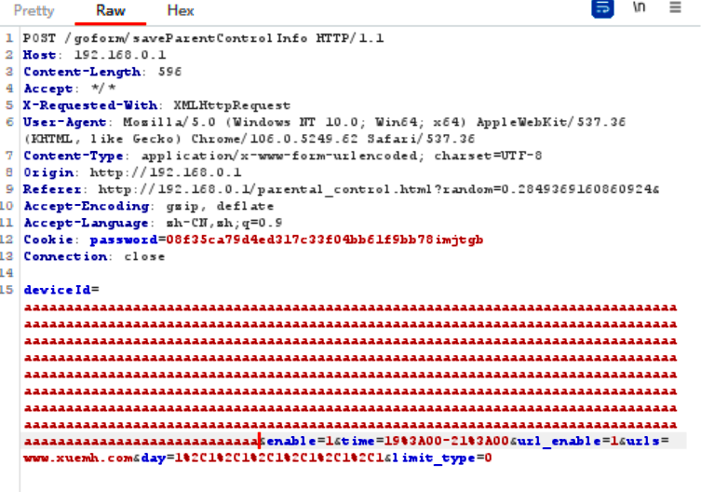

## 3. The saveParentControlInfo->compare_parentcontrol_time function has a stack overflow time parameter

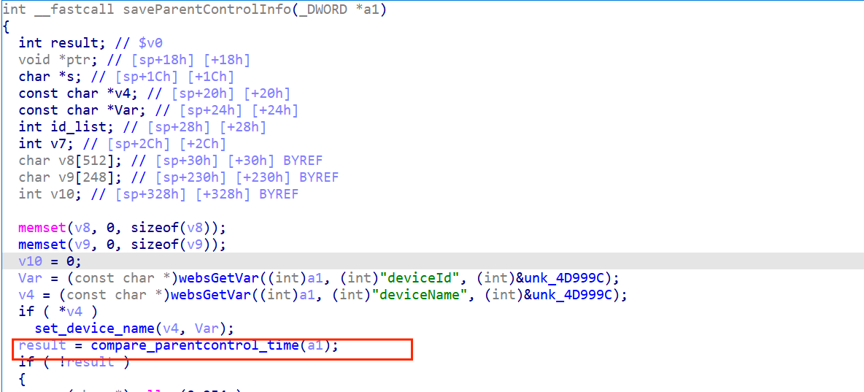

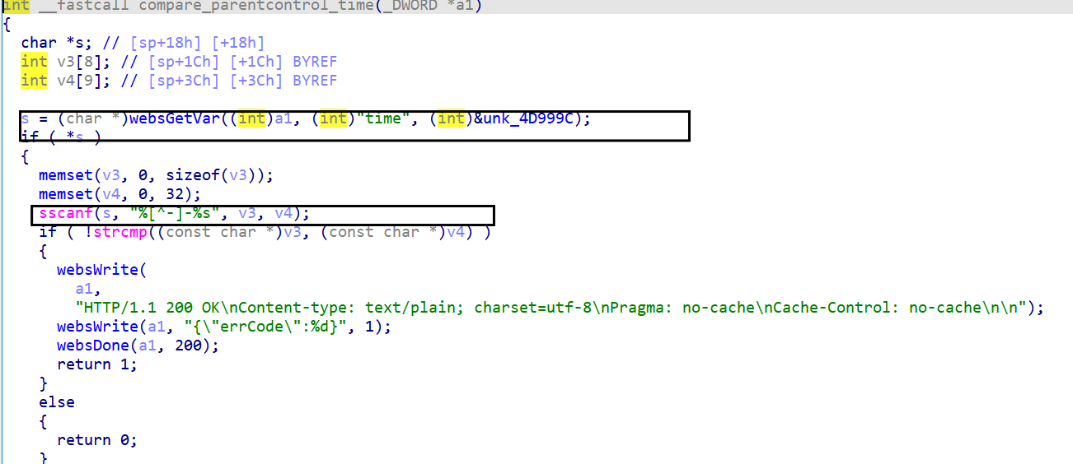

Poc:

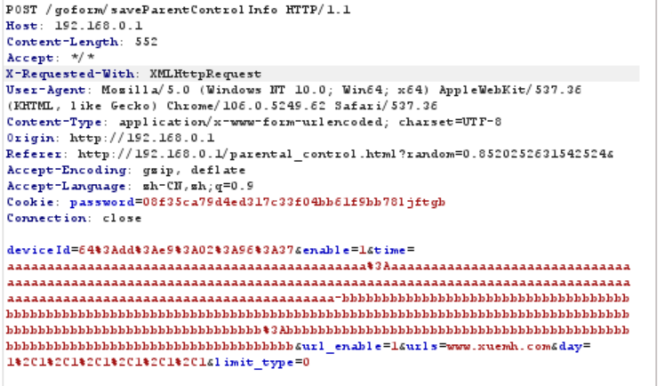

## 4. formSetPPTPServer->sub_4781A4 function has a stackoverflow

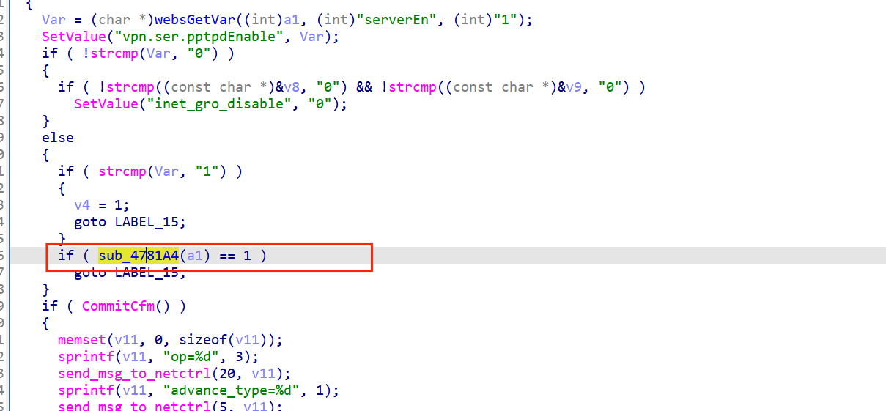

Sub_4781A4

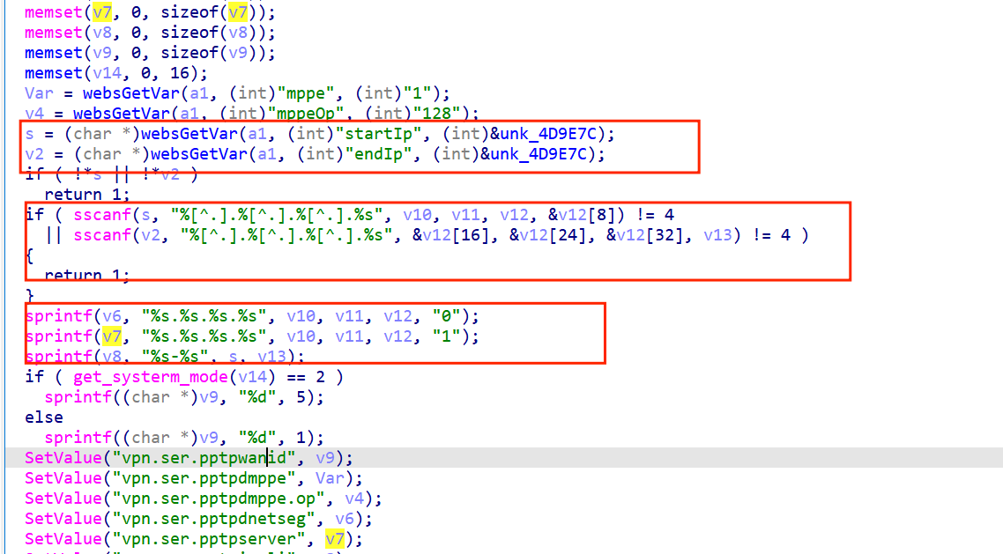

Poc：

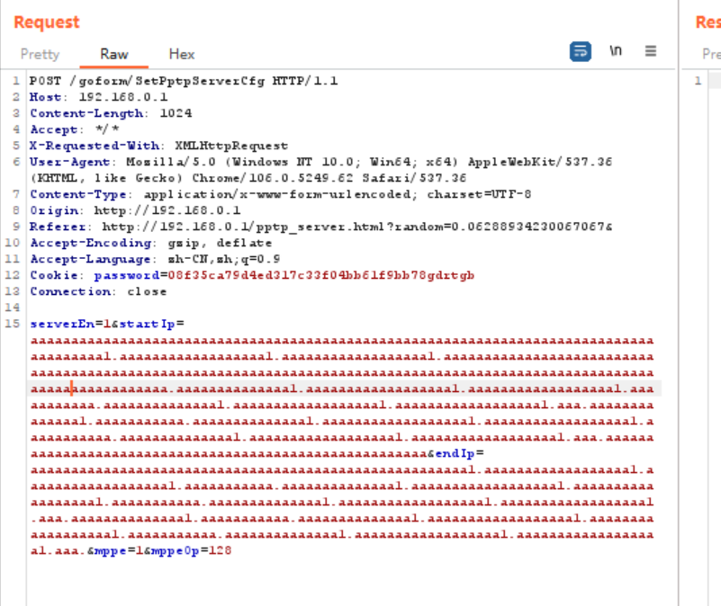

## 5. fromSetRouteStatic->save_staticroute_data has a stack overflow vulnerability

The parameter list is passed to save_staticroute_data causing this replication to be infinite, thus overflowing the stack 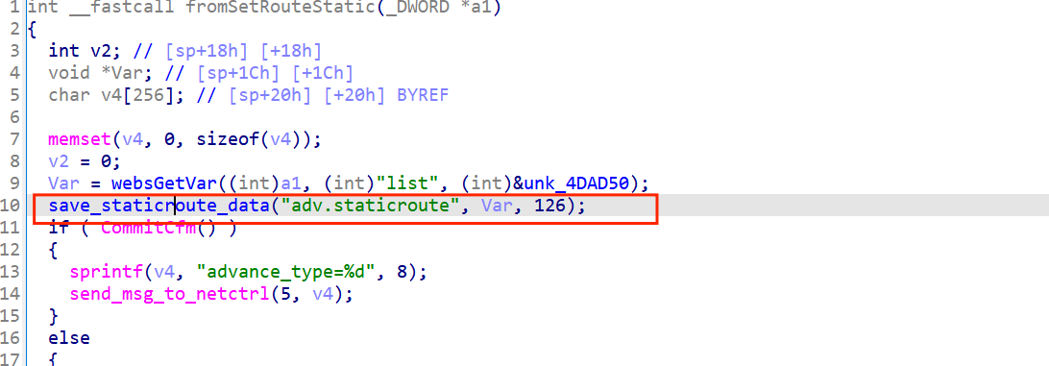

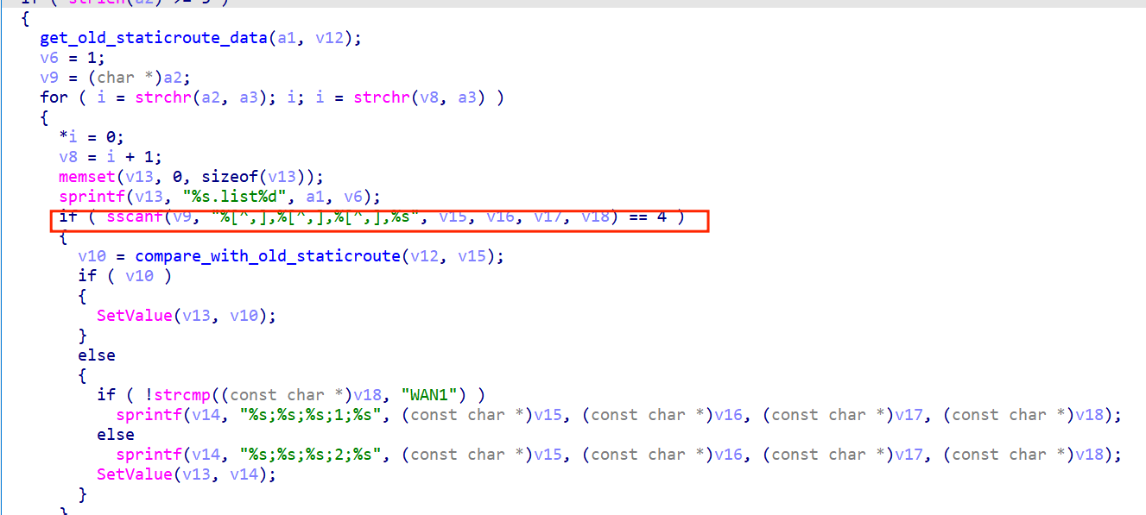

Poc：

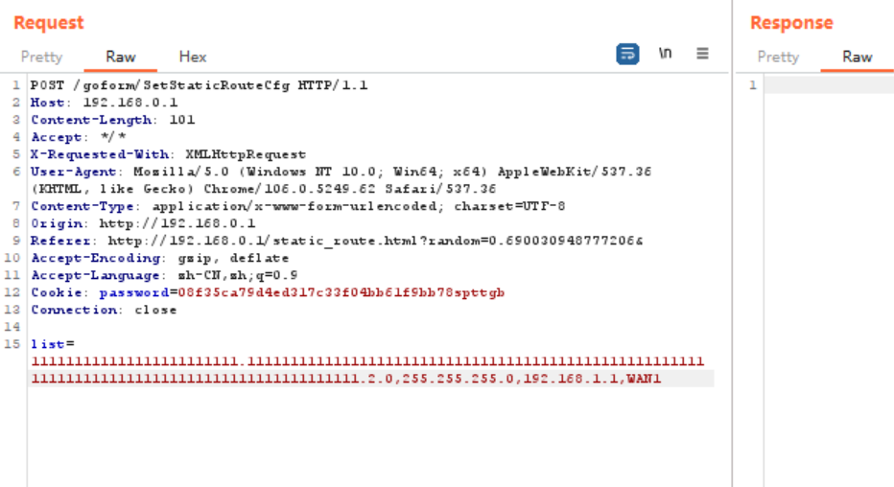

## 6. formSetVirtualSer->save_virtualser_data function a stack overflow vulnerability triggered by the list parameter

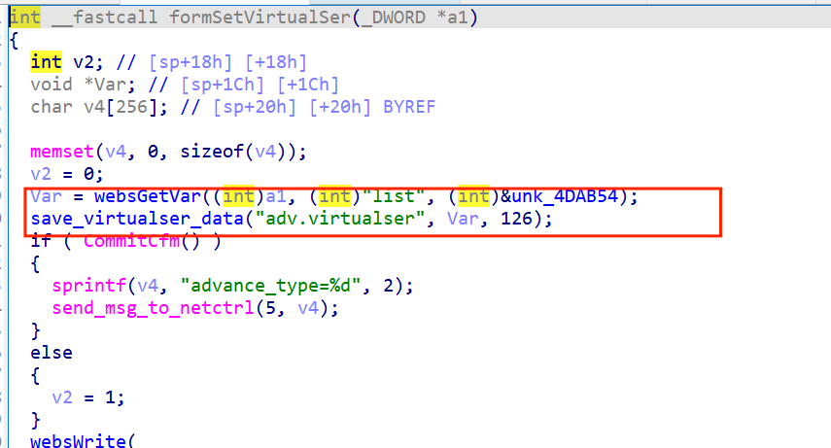

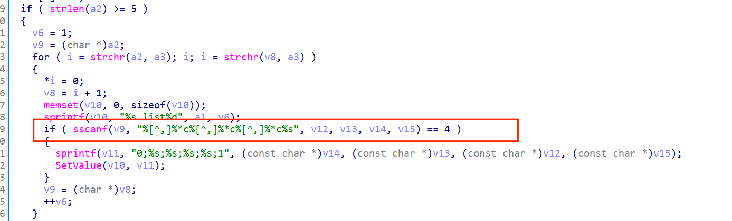

Poc:

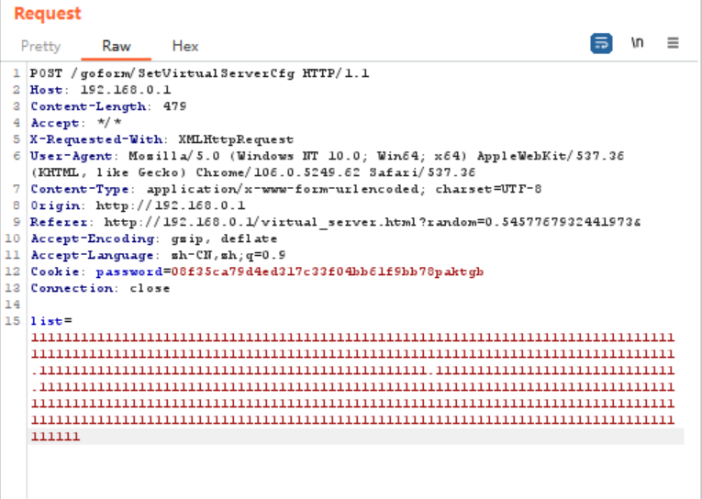

## 7. The mDMZSetCfg function parameter dmzIp has a stack overflow is triggered by the list parameter

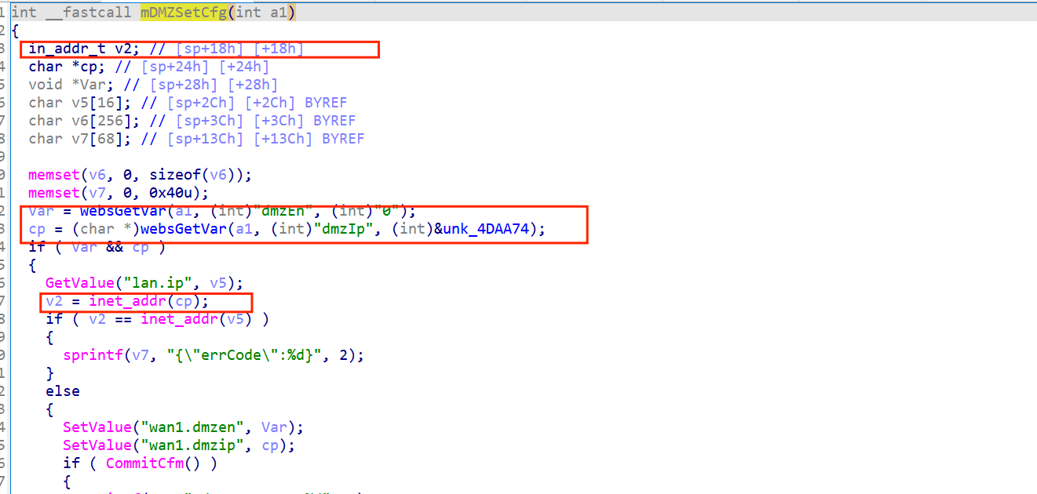

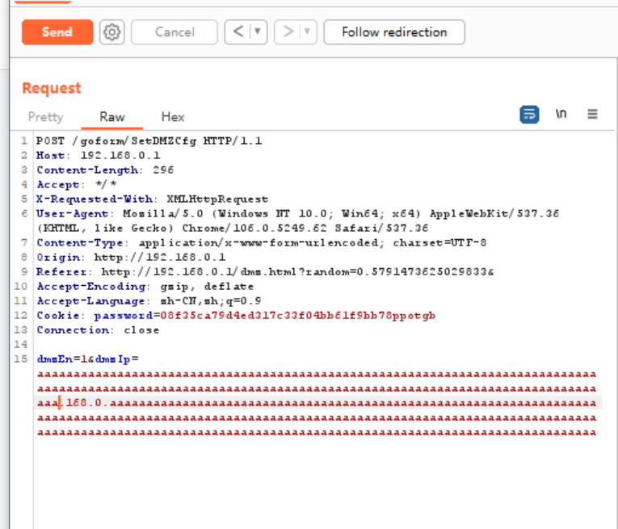

**8.The stack overflow is triggered in the fromSetIpMacBind->sub_48E668 stack overflow parameter list->sub_48E668** 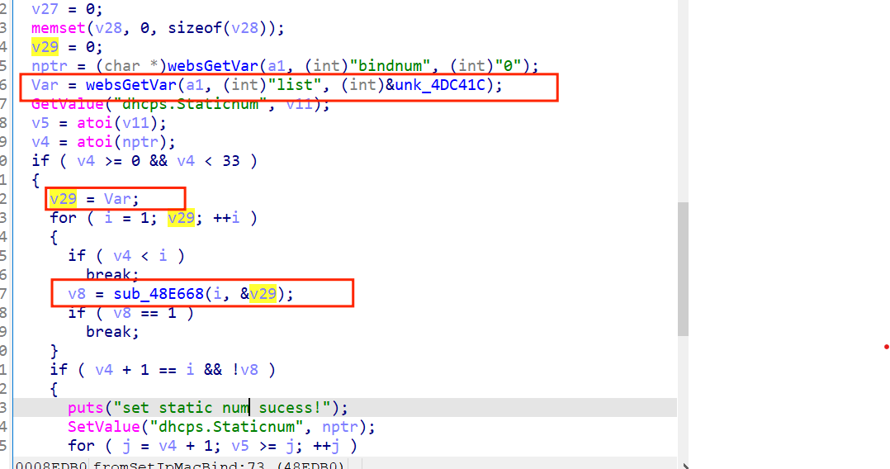

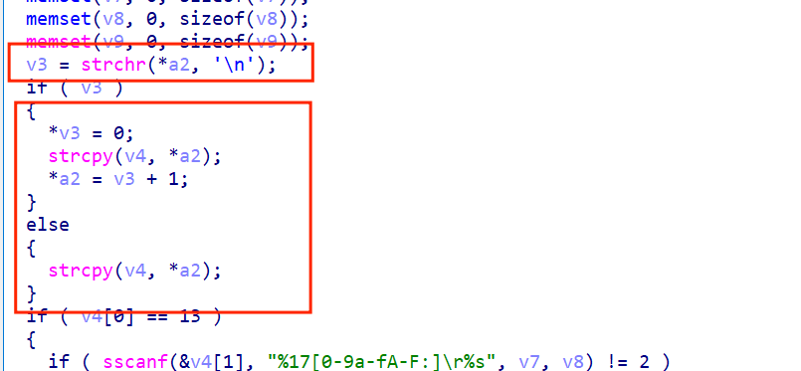

Poc:

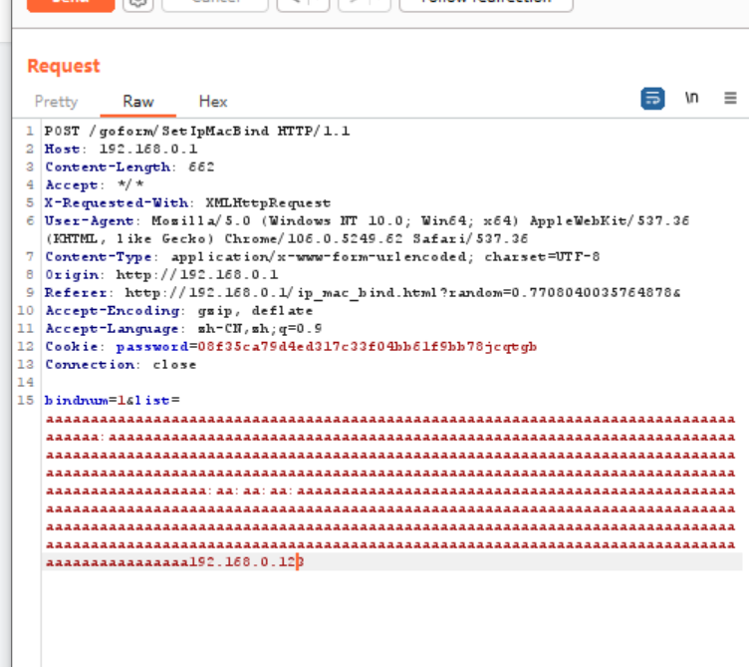

## 9. formSetRebootTimer->sub_497154 stack overflow: The parameter rebootTime->sub_497154 triggers stack overflow

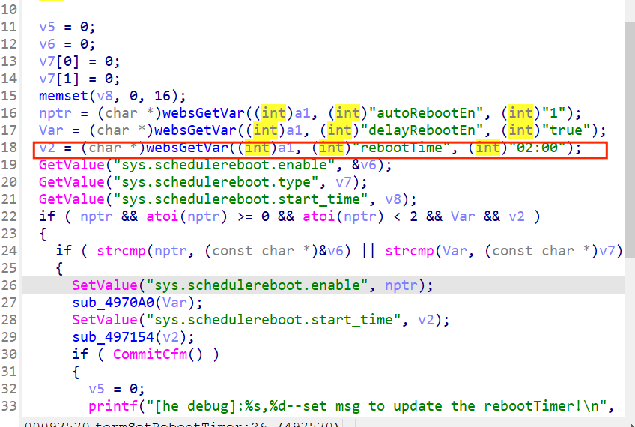

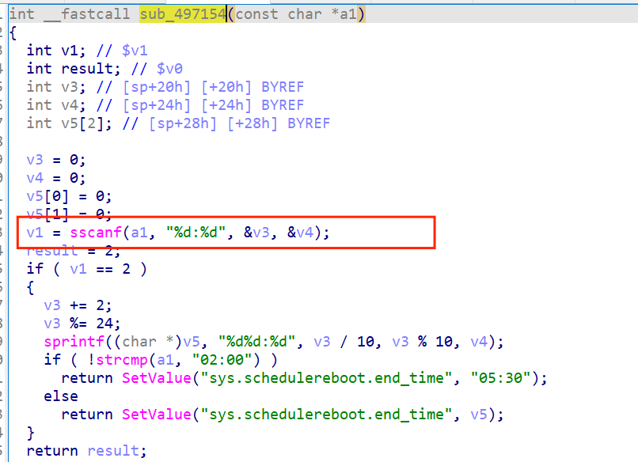

Poc：

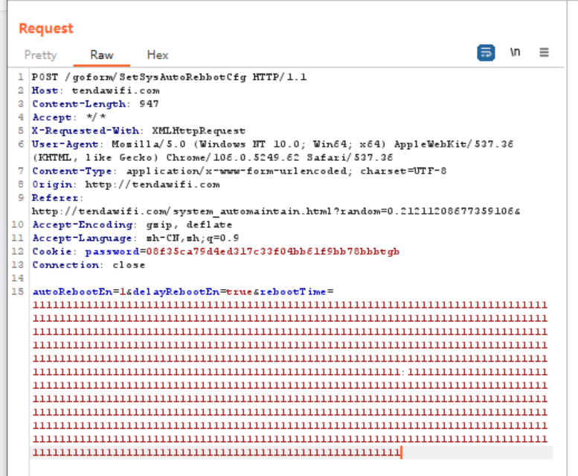

## 10. fromAdvSetMacMtuWan has a stack overflow vulnerability.Trigger function sub_44C7A8

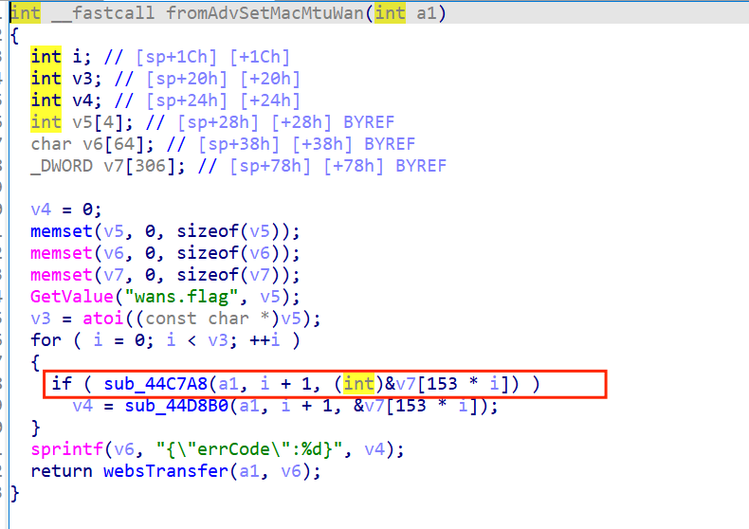

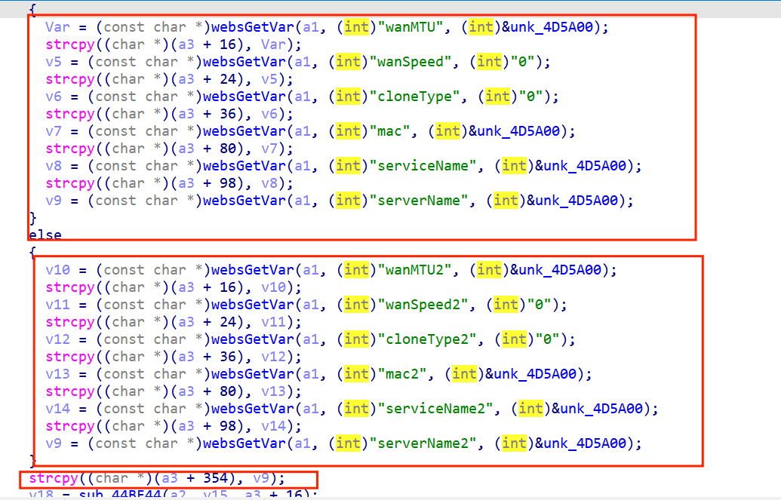

Poc：

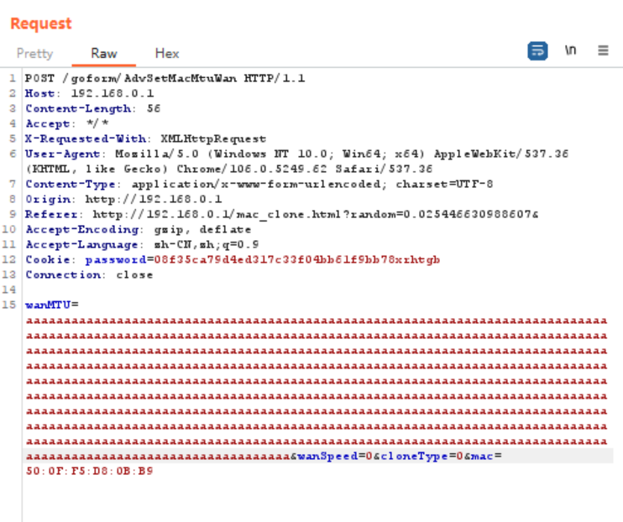

## 11.formWifiBasicSet->sub_451DF8->sub_450EE4->sub_450A4C

